**Create a S3 bucket, with no public access and upload files to the bucket & view the logs using cloudwatch for the uploaded files**

**S3**

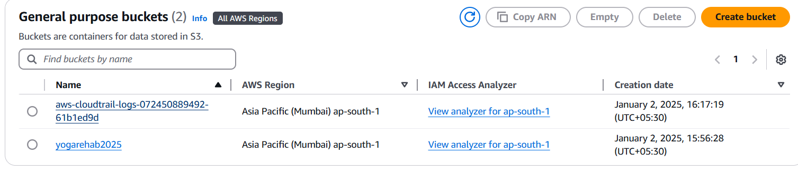

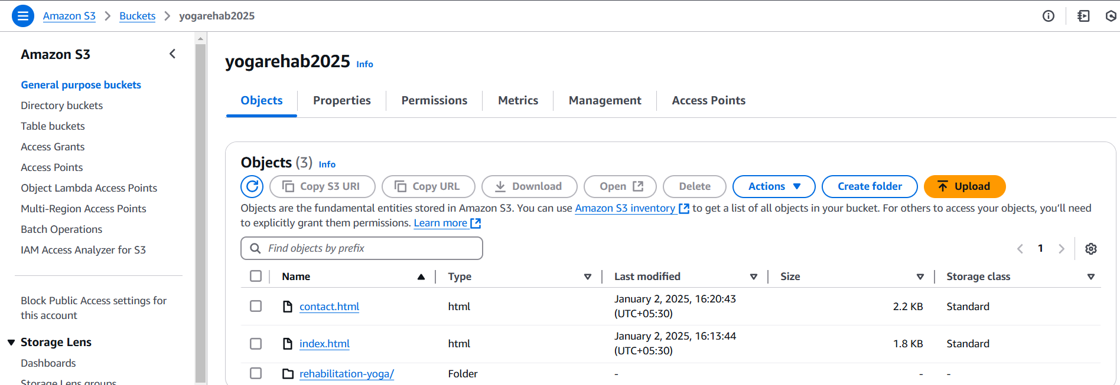

**Static Website**

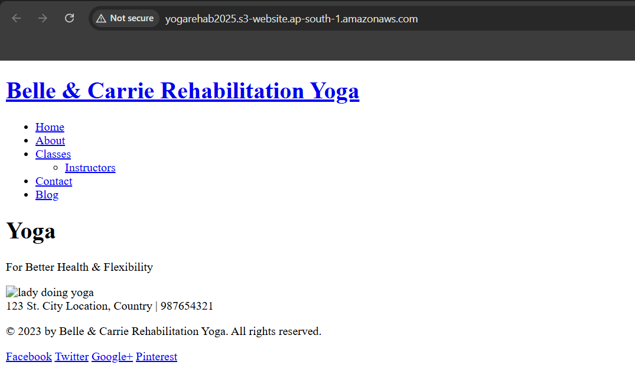

**LOGS**

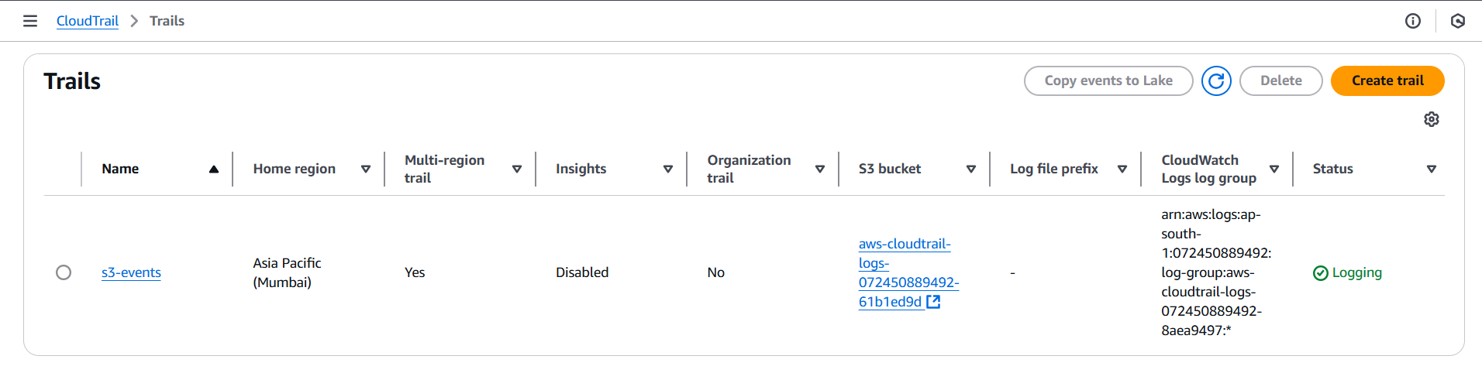

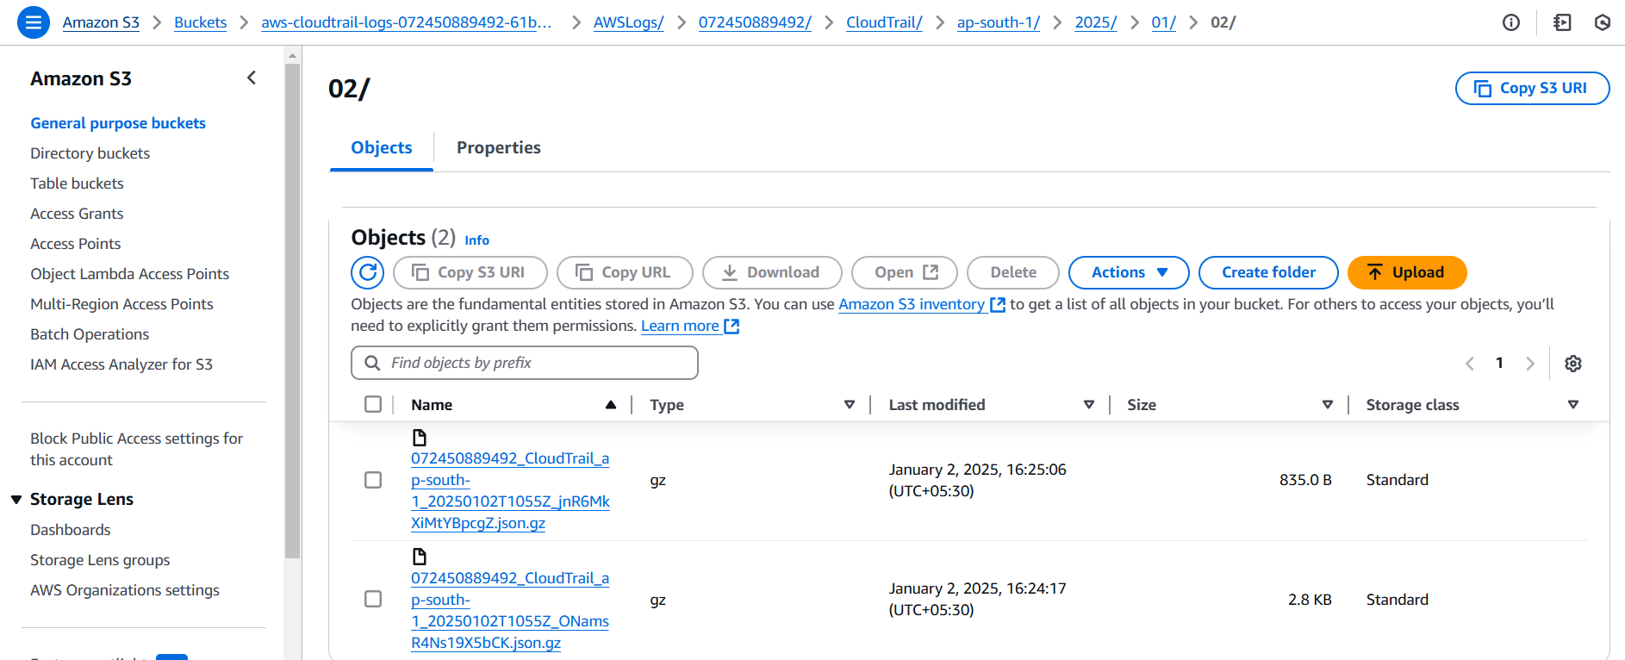

**Launch two ec2-instances and connect it to a application load balancer, where the output traffic from the server must be an load balancer IP address**

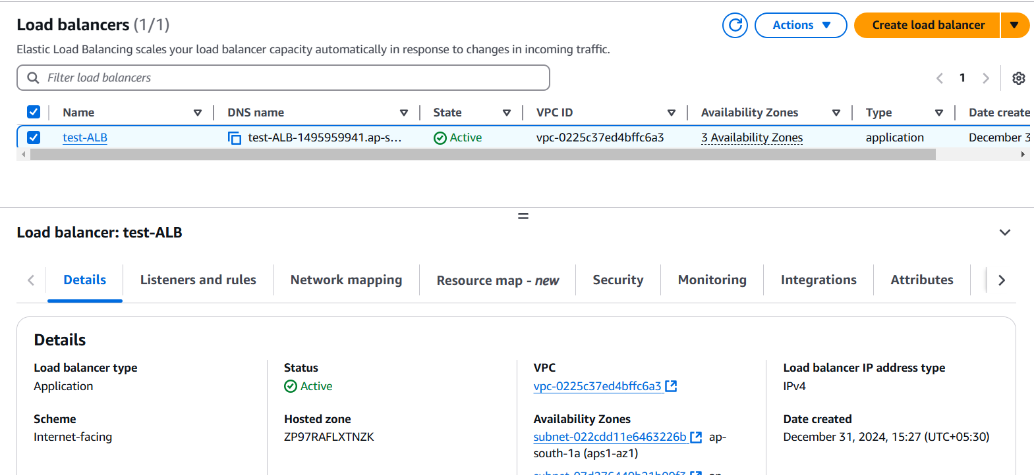

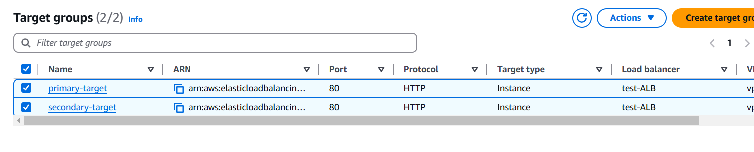

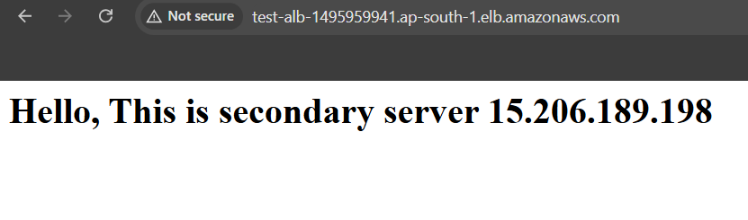

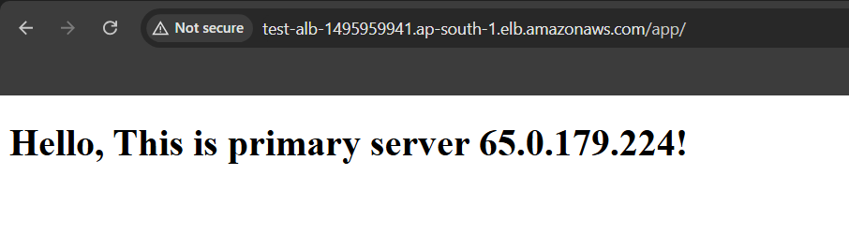

ALB IPs

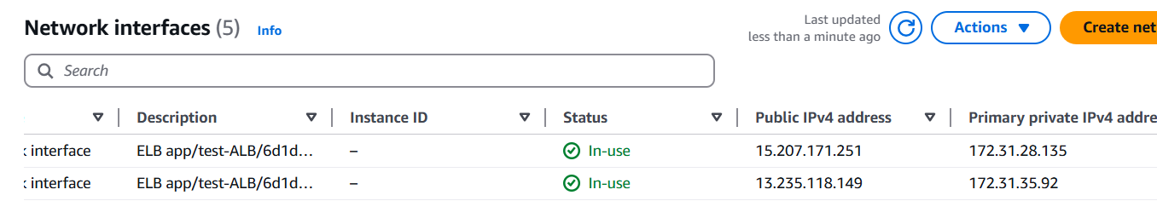

In primary server

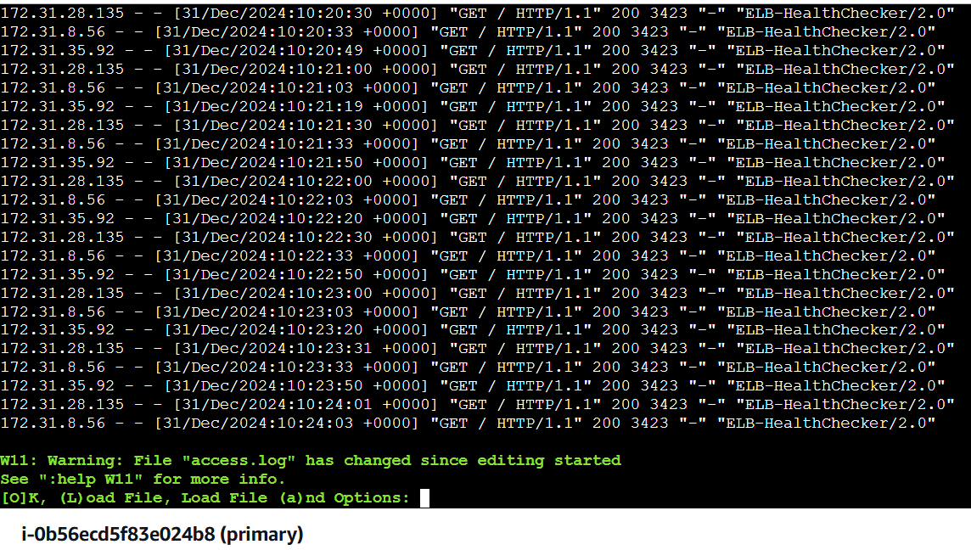

In secondary Server

